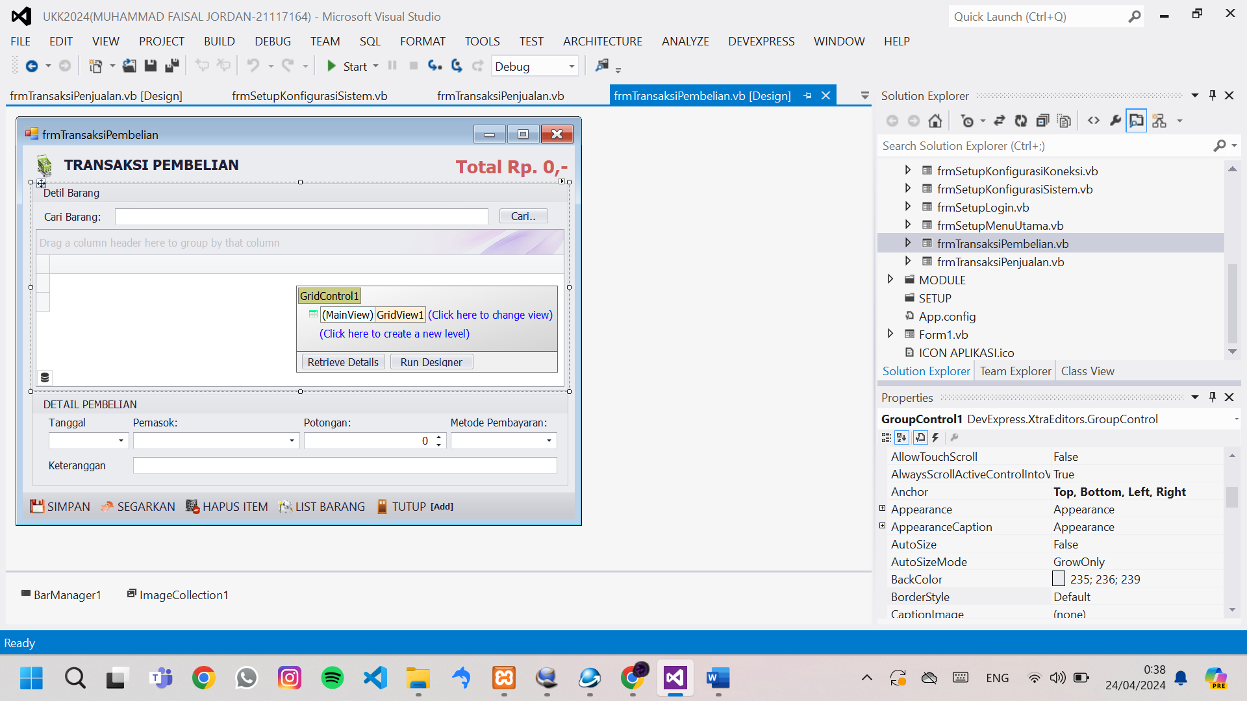

Public Class frmTransaksiPembelian

Dim Tampung As New DataTable

Dim TotalPembelian As Double

Sub TampilTotalHarga()

'menghitung dan menampikan kolom total_harga pada tabel

Dim Total As Double = 0

For Each isi In Tampung.Select()

Total = Total + isi.Item("TOTAL_HARGA")

Next

TotalPembelian = Total

txtTotal.Text = "Total Rp. " & Format(Total, "#,##0") & ",-"

GridView1.BestFitColumns()

End Sub

Sub TampilPemasok()

Dim Pemasok = EksekusiSQL("select * from pemasok ").Select()

txtPemasok.Properties.Items.Clear()

For Each isi In Pemasok

txtPemasok.Properties.Items.Add(isi.Item("NAMA_PEMASOK") & ">" & isi.Item("ID_PEMASOK"))

Next

End Sub

Sub TampilTable()

'menampilkan template dari tabel pembelian_detil

Tampung = EksekusiSQL("select JUMLAH,pembelian_detil.ID_BARANG,NAMA_BARANG,SATUAN,HARGA_SATUAN,TOTAL_HARGA from pembelian_detil,barang where pembelian_detil.ID_BARANG=barang.ID_BARANG and ID_PEMBELIAN=''")

GridControl1.DataSource = Tampung

End Sub

Sub Segarkan()

TampilTable() ' tampil ulang isi tabel

txtCari.Text = ""

txtTanggal.DateTime = Now

TampilPemasok() 'tampil ulang pilihan pemasok

txtPemasok.SelectedIndex = -1

txtPotongan.Value = 0

txtMetodePembayaran.SelectedIndex = 0

txtKeterangan.Text = ""

TotalPembelian = 0

TampilTotalHarga() 'tampil ulang label total

txtCari.Focus()

End Sub

Sub TambahItemBarang()

Dim CariBarang = EksekusiSQL("select * from barang where ID_BARANG='" & txtCari.Text & "'or BARCODE='" & txtCari.Text & "'").Select()

If CariBarang.Length > 0 Then 'pengecekan barang ada atau tidak

'disini lanjut

Dim CariDataTable = Tampung.Select("ID_BARANG='" & CariBarang(0).Item("ID_BARANG") & "'")

If CariDataTable.Length <= 0 Then

'tambah ke tabel

Dim DataBaru = Tampung.NewRow

DataBaru.Item("JUMLAH") = 1

DataBaru.Item("ID_BARANG") = CariBarang(0).Item("ID_BARANG")

DataBaru.Item("NAMA_BARANG") = CariBarang(0).Item("NAMA_BARANG")

DataBaru.Item("SATUAN") = CariBarang(0).Item("SATUAN")

DataBaru.Item("HARGA_SATUAN") = CariBarang(0).Item("HARGA_BELI")

DataBaru.Item("TOTAL_HARGA") = DataBaru.Item("JUMLAH") * DataBaru.Item("HARGA_SATUAN")

Tampung.Rows.Add(DataBaru) 'tambahkan isian baris baru pada tampung

TampilTotalHarga()

txtCari.Text = ""

txtCari.Focus()

Else

'tambah jumlahnya dan hitung ulang TOTAL_HARGA

CariDataTable(0).Item("JUMLAH") = CariDataTable(0).Item("JUMLAH") + 1

CariDataTable(0).Item("TOTAL_HARGA") = CariDataTable(0).Item("JUMLAH") * CariDataTable(0).Item("HARGA_SATUAN")

TampilTotalHarga()

txtCari.Text = ""

txtCari.Focus()

End If

Else

MessageBox.Show("barang tidak di temukan .", "Validasi", MessageBoxButtons.OK, MessageBoxIcon.Warning)

txtCari.Text = ""

txtCari.Focus()

End If

End Sub

Sub HapusItemBarang()

If GridView1.RowCount <= 0 Then

MessageBox.Show("Item barang barang belum di tambahkan.", "Validasi", MessageBoxButtons.OK,

MessageBoxIcon.Warning)

Exit Sub

End If

If MessageBox.Show("item barang akan di hapus. lanjutkan?", "Validasi", MessageBoxButtons.YesNo, MessageBoxIcon.Question) = Windows.Forms.DialogResult.Yes Then

GridView1.DeleteSelectedRows()

TampilTotalHarga()

txtCari.Text = ""

txtCari.Focus()

End If

End Sub

Sub ListBarang()

frmListBarang.NilaiKiriman = 1

frmListBarang.WindowState = FormWindowState.Maximized

frmListBarang.ShowDialog()

End Sub

Sub Simpan()

'pengecekan data

If txtTanggal.Text = "" Or txtPemasok.Text = "" Or txtMetodePembayaran.Text = "" Then

MessageBox.Show("Tanggal, Pemasok, dan Metode Pembayaran wajib diisi.", "Validasi", MessageBoxButtons.OK, MessageBoxIcon.Warning)

Exit Sub

End If

If GridView1.RowCount <= 0 Then

MessageBox.Show("Data item belum ditambahkan.", "Validasi", MessageBoxButtons.OK, MessageBoxIcon.Warning)

Exit Sub

End If

'pembuatan kode otomatis (auto increment)

Dim NomorTransaksi As Integer

Try

NomorTransaksi = Val(EksekusiSQL("select max(ID_PEMBELIAN) as ID_PEMBELIAN from pembelian").Select()(0).Item("ID_PEMBELIAN")) + 1

Catch ex As Exception

NomorTransaksi = 1

End Try

'mengisi tabel pembelian

EksekusiSQL("insert into pembelian(ID_PEMBELIAN,TANGGAL,ID_PEMASOK,TOTAL_PEMBELIAN,POTONGAN,METODE_PEMBAYARAN,KETERANGAN,ID_PENGGUNA) values('" & NomorTransaksi & "','" & Format(txtTanggal.DateTime, "yyyy-MM-dd") & "','" & txtPemasok.Text.Split(">")(1) & "','" & TotalPembelian & "','" & txtPotongan.Value & "','" & txtMetodePembayaran.Text & "','" & txtKeterangan.Text & "','" & My.Settings.lgnID & "')")

'mengisi tabel pembelian detil

For Each isi In Tampung.Select()

EksekusiSQL("insert into pembelian_detil(ID_PEMBELIAN,ID_BARANG,HARGA_SATUAN,JUMLAH,TOTAL_HARGA) values('" & NomorTransaksi & "','" & isi.Item("ID_BARANG") & "','" & isi.Item("HARGA_SATUAN") & "','" & isi.Item("JUMLAH") & "','" & isi.Item("TOTAL_HARGA") & "')")

'koding ngojek untuk merubah/menambah stok pada barang

' Dim Stok = EksekusiSQL("select STOK from barang where ID_BARANG='" & isi.Item("ID_BARANG") & "'").Select()(0).Item("STOK")

' Dim StokBaru = isi.Item("JUMLAH") + Stok

'mengubah data stok dengan stok baru

' EksekusiSQL("update barang set STOK='" & StokBaru & "' where ID_BARANG='" & isi.Item("ID_BARANG") & "'")

Next

'pembersihan ulang

Segarkan()

MessageBox.Show("Transaksi Berhasil.", "Informasi", MessageBoxButtons.OK, MessageBoxIcon.Information)

'akan ada koding cetak di sini lain waktu

End Sub

Sub Tutup()

If GridView1.RowCount > 0 Then

If MessageBox.Show("Transaksi akan ditutup . lanjutkan?", "Validasi", MessageBoxButtons.YesNo, MessageBoxIcon.Question) = Windows.Forms.DialogResult.Yes Then

Me.Close()

End If

Else

Me.Close()

End If

End Sub

Private Sub SimpleButton1_Click(sender As Object, e As EventArgs) Handles SimpleButton1.Click

TambahItemBarang()

End Sub

Private Sub frmTransaksiPembelian_KeyDown(sender As Object, e As KeyEventArgs) Handles Me.KeyDown

Select Case e.KeyCode

Case Keys.Enter

TambahItemBarang()

Case e.Control And Keys.S

Simpan()

Case Keys.F5

Segarkan()

Case e.Control And Keys.D

HapusItemBarang()

Case Keys.F1

ListBarang()

Case Keys.Escape

Tutup()

End Select

End Sub

Private Sub frmTransaksiPembelian_Load(sender As Object, e As EventArgs) Handles MyBase.Load

Me.KeyPreview = True

GridView1.OptionsView.ShowGroupPanel = False ' menghilangkan grup panel

GridView1.OptionsView.ColumnAutoWidth = False ' supaya colom tidak mengikuti ukuran table

txtPemasok.Properties.TextEditStyle = DevExpress.XtraEditors.Controls.TextEditStyles.DisableTextEditor

txtMetodePembayaran.Properties.TextEditStyle = DevExpress.XtraEditors.Controls.TextEditStyles.DisableTextEditor

Segarkan()

GridView1.Columns("ID_BARANG").OptionsColumn.AllowEdit = False

GridView1.Columns("NAMA_BARANG").OptionsColumn.AllowEdit = False

GridView1.Columns("TOTAL_HARGA").OptionsColumn.AllowEdit = False

End Sub

Private Sub GridView1_CellValueChanged(sender As Object, e As DevExpress.XtraGrid.Views.Base.CellValueChangedEventArgs) Handles GridView1.CellValueChanged

'pengecekan kolom yang di rubah

Select Case e.Column.GetTextCaption

Case "JUMLAH"

'hitung total harga

Dim TotalHarga = GridView1.GetFocusedRowCellValue("JUMLAH") * GridView1.GetFocusedRowCellValue("HARGA_SATUAN")

GridView1.SetFocusedRowCellValue("TOTAL_HARGA", TotalHarga)

Case "HARGA_SATUAN"

'hitung total harga

Dim TotalHarga = GridView1.GetFocusedRowCellValue("JUMLAH") * GridView1.GetFocusedRowCellValue("HARGA_SATUAN")

GridView1.SetFocusedRowCellValue("TOTAL_HARGA", TotalHarga)

End Select

TampilTotalHarga()

End Sub

Private Sub BarButtonItem2_ItemClick(sender As Object, e As DevExpress.XtraBars.ItemClickEventArgs) Handles BarButtonItem2.ItemClick

Simpan()

End Sub

Private Sub BarButtonItem3_ItemClick(sender As Object, e As DevExpress.XtraBars.ItemClickEventArgs) Handles BarButtonItem3.ItemClick

Segarkan()

End Sub

Private Sub BarButtonItem5_ItemClick(sender As Object, e As DevExpress.XtraBars.ItemClickEventArgs) Handles BarButtonItem5.ItemClick

HapusItemBarang()

End Sub

Private Sub BarButtonItem6_ItemClick(sender As Object, e As DevExpress.XtraBars.ItemClickEventArgs) Handles BarButtonItem6.ItemClick

ListBarang()

End Sub

Private Sub BarButtonItem7_ItemClick(sender As Object, e As DevExpress.XtraBars.ItemClickEventArgs) Handles BarButtonItem7.ItemClick

Tutup()

End Sub

Private Sub txtTotal_Click(sender As Object, e As EventArgs) Handles txtTotal.Click

End Sub

End Class